

# AI and the Global Economy

#### Machine Learning and the Market for Intelligence Conference

**Rotman School of Management, University of Toronto**

##### Mark Carney

Governor, Bank of England

23 October 2018



2

Employment population ratio

**(per cent)**

**60**

**1st IR 2nd IR 3rd IR**

Unemployment rate

**(per cent)**

**24**

**50 20**

**Employment population ratio**

**40 16**

**30 12**

**Unemployment rate**

**20 8**

**10 4**

**0**

**1760 1780 1800 1820 1840 1860**

**1880 1900 1920 1940 1960**

**0**

**1980 2000** 3

**Output per worker**

**(Index: 1900 = 100)**

**70**

**Real wage**

**(Index: 1900 = 100)**

**70**

**60 Engels' Pause -**

**Growth in output per worker exceeds real wage growth**

**50**

**Output per worker**

**60**

**40 50**

**Real**

**30 wage**

**40**

**20**

**10 30**

**1770 1780 1790 1800 1810 1820 1830 1840 1850 1860 1870**

4

Source: A Millennium of Data, Bank of England. Note: series are ten year moving averages



5





6

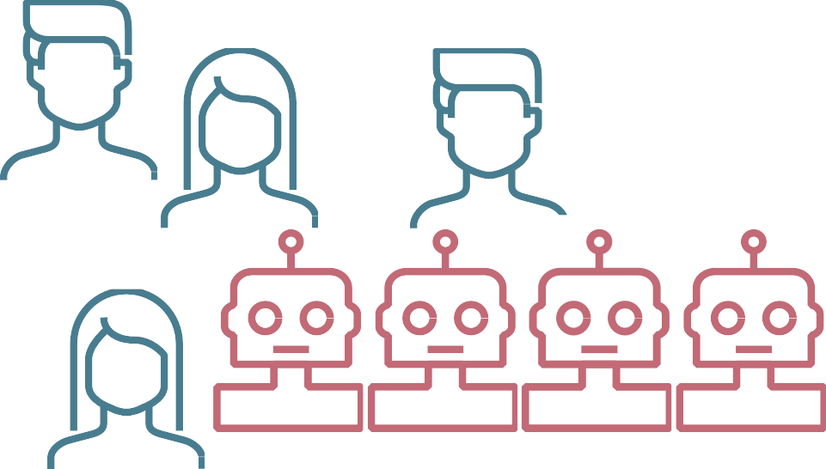

7

**Per cent**

**56**

**Labour share**

**Percentage change relative to 1990**

**25**

**55 20**

**54 15**

**53 10**

**52 5**

**51 0**

**50 -5**

**49**

**48 Relative price of investment**

**-10**

**-15**

**47 -20**

**46**

**1970 1975 1980 1985 1990 1995 2000 2005 2010 2015**

**-25**

Source: IMF April 2017 WEO. Notes: the chart shows the labour share and relative price of investment across advanced economies. 8

100 x Change in Employment Share

**0.20**

Expanding

**0.15**

**0.10**

**Growth of low-skilled jobs**

**0.05**

**2007-2012**

**Growth of high- skilled jobs**

**0.00**

**1999-2007**

**0 20 40 60 80 100**

**-0.05**

Shrinking

**-0.10**

**1989-1999**

**1979-1989**

**Skill percentile**

**(ranked by occupation’s 1979 mean log wage)**

9

Source: Autor, D (2015) ‘Why Are There Still So Many Jobs? The History and Future of Workplace Automation’, *Journal of Economic Perspectives*, Vol. 29, No. 3, pp.3-30.

**Real wage level of full time U.S. male workers relative to 1963**

**2.0**

**1.8**

**Greater than**

**Bachelor’s Degree**

**High School Dropout**

**Bachelor’s Degree**

**Some College**

**High School Graduate**

**1.6**

**1.4**

**1.2**

**1.0**

**0.8**

**1963 1968 1973 1978 1983 1988 1993 1998 2003 2008**

10

Source: Autor (2014) ‘Education, and the Rise of Earnings Inequality Among the "Other 99 Percent“, *Science*, 23 May 2014, pp 843–851.

**Jobs with tasks at risk by 2030**

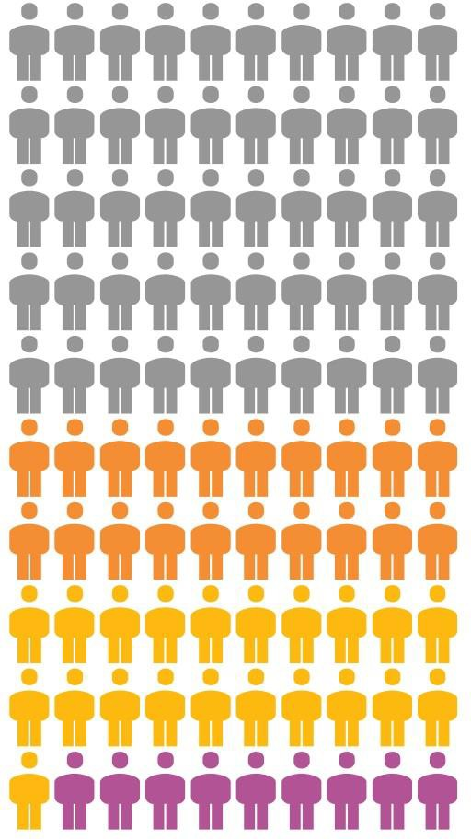

**Norway Finland Sweden**

**New Zealand United States**

**Korea Denmark Netherlands United Kingdom**

**United Kingdom**

**Estonia**

**Canada**

**50%**

*Frey & Osborne (2017)*

***McKinsey (2016)***

**Singapore Canada Belgium**

###### 30%

*PwC (2016)*

**9% *Arntz et al. (2016)***

**All countries in sample**

**Japan Italy**

**All countries in sample**

**Czech Republic**

**Ireland France Austria Germany Poland Spain**

**Slovak Republic**

**0 10 20**

**30 40**

**Percentage of jobs at high risk of automation**

Source: Nedelkoska, L and Quintini, G (2018), “Automation, skills use and 11

training”, OECD Social, Employment and Migration Working Paper.

**Technology adoption lag (years)**

**140**

**120**

**100**

**80**

Steam- and motorships

Railways - passengers



Railways - freight

**60**

Telegrams

**40**

Telephones

Cars

Trucks

Electricity

Aviation - freight Aviation - passengers

**20** Blast oxygen

MRI units

**0**

Cellphones PCs

Internet users

**1750 1800 1850 1900 1950 2000**

Notes: Technology adoption lag is a mean estimated lag in cross-country technology diffusion.

**Invention year of technology**

12

Source: Comin, D and Hobijn, B (2010), ‘An exploration of technology diffusion’, *American Economic Review*, Vol. 100, No. 5, pp2031-59.

# This time it’s faster?

**1st IR 2nd IR 3rd IR 4th IR?**

**Annual change in sectoral**

**(54 years)**

**(66 years) (34 years)**

**(20 years?)**

**employment shares (pp)**

**2.0**



**Services**

**Agriculture & Mining**

**Manufacturing**

**1817-1871**

**1871-1937**

**1973-2007**

**2018 - ?**

**Expanding**

**1.5**

**1.0**

**0.5**

**0.0**

**-0.5**

**-1.0**

**-1.5**

**-2.0**

**2018-2030**

**Shrinking**

13

|  |  |  |
| --- | --- | --- |
| **Institution** | **Effect** | **Examples** |

|  |  |  |
| --- | --- | --- |
| **Enabling institutions** | Transform the skill base of workers | Spread of primary, secondary, tertiary  and technical education |

|  |  |  |
| --- | --- | --- |
| **New insurance institutions** | Support those displaced | Unemployment insurance, universal healthcare, state pensions, child benefit |

|  |  |  |
| --- | --- | --- |
| **Labour market institutions** | Provide income support and share out the  surplus | Friendly Societies, Trade Unions, Co-  operatives, minimum wages |

14

|  |  |  |
| --- | --- | --- |
| **Employers** | Create environments to help employees thrive | “Model Villages” (providing housing, schooling and recreation), higher pay (Ford’s $5 initiative), occupational pensions |

|  |  |
| --- | --- |
| **Institution** | **Solution** |
| **Business** | * Identify skills mismatches, adopt anticipatory talent management to train   workers   * Explore opportunities to maximise job-creating, augmented intelligence |
| **Labour market institutions** | * Balance labour mobility with protections of workers in new, non-standard jobs * Establish new class of “dependent contractor” for platform-based workers * Utilise tech solutions to match and bridge skills gaps * Make data portable (including reputational history of platform-based workers) |
|  |  |
| **Enabling institutions** | * Quaternary education (mid-career, integrated with social welfare system) * Universal support schemes for retraining (UK’s Flexible Learning Fund) |
| **Finance** | **AI could potentially:**   * **Improve customer choice, services and pricing** * **Increase access to credit for households and SMEs** * **Substantially lower cross border transaction costs** * **Improve diversity and resilience of the system** |

15



16

Judgement

= Data



Input

Prediction

Action

Outcome

Feedback

Training

17

Source: “What managers need to know about Artificial Intelligence” Sloan Management Review, by Ajay Agrawal, Joshua Gans and Avi Goldfarb 2017

**Payment services**

**Digital wallets, eMoney, cross- border payments**

**Data**



**APIs, chatbots, comparison and switching tools, robo advisors, identity verification**

**Retail and commercial banking**

**Customer relationship**

**flow**

**Universal Bank**

18

**Wholesale banking, markets**

**Digital wallets, eMoney, cross- border payments**



**Retail and commercial banking**

**Customer relationship**

**Platform lending,**

**big data analytics, risk evaluation/credit scoring**

**Data flow**

**APIs, chatbots, comparison and switching tools, robo advisors, identity verification**

**Payment services**

19

**Wholesale banking, markets**

**Universal Bank**

# SME finance: current challenges

**£22bn**

the estimated funding shortfall for UK SMEs

**45%**

of SMEs do not use or plan to use external finance

**2/5ths**

of SME loan applicants are rejected

20

Source: BVA BDRC (consumer insight consultancy) survey of SMEs; NAO report ‘improving access to finance for SMEs’; ibid

## The financial value chain

**Platform lending,**

**big data analytics, risk evaluation/credit scoring**

**APIs, chatbots, comparison and switching tools, robo advisors, identity verification**

**Retail and commercial banking**

**Customer relationship**

**Payment services**

**Digital wallets, eMoney, cross- border payments**



21

**Algorithmic and automated trading**

**Wholesale banking, markets**

**Universal Bank**

|  |  |  |  |
| --- | --- | --- | --- |
| **Market** | **Electronification**  **(as share of overall mkt size)** | **Principle trading firm presence** | **Automated trading?** |
| **Futures** | 90% | High | Yes, incl AI |

|  |  |  |  |
| --- | --- | --- | --- |
| **US equities** | 80% | High | Yes, incl AI |

|  |  |  |  |
| --- | --- | --- | --- |
| **Spot foreign**  **exchange** | 65% | High | Yes, incl AI |

|  |  |  |  |
| --- | --- | --- | --- |
| **US government**  **bonds** | 60-80%  (90%+ for on-the-run) | High | Some |

|  |  |  |  |
| --- | --- | --- | --- |
| **European**  **government bonds** | 60% | Low | Little |

|  |  |  |  |
| --- | --- | --- | --- |
| **US high-yield bonds** | 25% | Low | Little |

22



23

# AI does well in finance when…

### There are known knowns with a clearly defined question, the future is expected to behave like the past, and sufficient past data to infer conclusions (for example, fraud detection, AML/CFT and insurance underwriting)

* Markets have set rules such that speed, consistency and efficiency favour disciplined arbitrage (e.g. index rebalancing, mean reversion)
* It provides an initial prediction that humans can combine with their assessments or a second opinion to prompt further review (credit and compliance assessments)
* It overcomes human biases such as loss aversion or hyperbolic discounting

24

# AI for inclusive growth

**Embrace** the promise of fintech for households and SMEs

* greater financial inclusion
* more tailored products
* keener pricing
* more diverse sources of credit

**Enable** new technologies by developing

* hard infrastructure - such as large value payments systems, RTGS
* soft infrastructure, including rules and regulations, and capturing data in a consistent and useable form (LEI)

25

**Empower** new providers to promote competition

* lower barriers to entry through proportionate supervision
* level the playing field to allow new players to access hard infrastructure (e.g. Non-bank PSPs)

**Platform lending,**

**big data analytics, risk evaluation/credit scoring**

**APIs, chatbots, comparison and switching tools, robo advisors, identity verification**

**Retail and commercial banking**

**Customer relationship**

**Payment services**

**Digital wallets, eMoney, cross- border payments**



26

**Algorithmic and automated trading**

**Wholesale banking, markets**

**RTGS**

**Wholesale payments, clearing and**

**settlement infrastructure**

**Universal Bank**

**Best in class messaging standards** ISO 20022 and

Legal Entity Identifiers

**Non-bank RTGS access** Admitting innovative payment providers



RTGS

**DLT plug and play with RTGS**

Future proofing so that DLT payments systems can plug into RTGS



**Synchronisation**

Exploring how to synchronise with other systems for efficiency and connectivity

27

Judgement

* + *Regulatory data (DRR)*



Input

Prediction

Action

Outcome

* *Rulebook*
* *Supervisory*

*strategy*

Feedback

= Data

Training

28

Source: “What managers need to know about Artificial Intelligence” Sloan Management Review, by Ajay Agrawal, Joshua Gans and Avi Goldfarb 2017

* The implications of structural shifts and long-term value drivers (like demographics, climate change and AI itself!)
* Too little data (known unknowns—Knightian uncertainty)
* The auditability and interpretability of black box algorithms
* Increased dependency on third parties, single points of failure outside regulatory perimeter
* Bias in data and increased interconnections could lead to potentially pro- cyclical behaviour
* Fundamental trade-offs between innovation and competition and performance and privacy

29

**Embrace** the promise of fintech for households and SMEs

* greater financial inclusion
* more tailored products
* keener pricing
* more diverse sources of credit

**Enable** new technologies by developing the right

* hard infrastructure - such as large value

payments systems, RTGS

* soft infrastructure, including rules and regulations, and capturing data in a consistent and useable form (LEI)

**Empower** new providers to promote competition

* lower barriers to entry through proportionate supervision
* level the playing field to allow new players to access hard infrastructure (e.g. Non-bank PSPs)

**Ensure** fintech develops in a way that

maximises the opportunities and minimises the risks for society

30



# AI and the Global Economy

#### Machine Learning and the Market for Intelligence Conference

**Rotman School of Management, University of Toronto**

##### Mark Carney

Governor, Bank of England

23 October 2018